Syllabic Writing system

what is Syllabic Writing system
# Source: Chatgpt (GPT-4-turbo) at [7/21/2025]
A syllabic writing system is a type of writing system in which each symbol (character) represents a syllable—a unit of sound that typically consists of a consonant + vowel (like ka, mi, or to), a vowel alone (a, e), or sometimes consonant + vowel + consonant.

🔡 Key Features of Syllabic Writing Systems:
# Source: Chatgpt (GPT-4-turbo) at [7/21/2025]
- Symbols Represent Syllables
  - Each symbol stands for a whole syllable, not an individual sound or letter.
  - Example: One symbol might represent "ka", another "mi", and so on.
- No Separate Letters for Individual Consonants or Vowels
  - Unlike alphabets, you won’t find separate letters for "k" or "a"—they’re built into the syllable symbol.
- System Size
  - Syllabaries usually have dozens to hundreds of symbols, depending on the number of possible syllables in the language.

📝 Examples of Syllabic Writing Systems:
# Source: Chatgpt (GPT-4-turbo) at [7/21/2025]
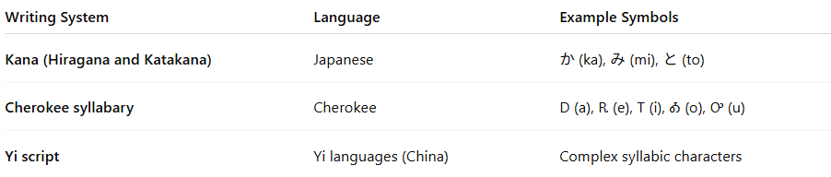
Writing System | Language | Example Symbols
Kana (Hiragana and Katakana) | Japanese | か (ka), み (mi), と (to)
Cherokee syllabary | Cherokee | Ꭰ (a), Ꭱ (e), Ꭲ (i), Ꭳ (o), Ꭴ (u)
Yi script | Yi languages (China) | Complex syllabic characters

✅ Advantages:
# Source: Chatgpt (GPT-4-turbo) at [7/21/2025]
- Simple and direct for languages with a limited number of syllables.
- Easy to learn for native speakers, especially in phonologically simple languages.

⚠️ Limitations:
# Source: Chatgpt (GPT-4-turbo) at [7/21/2025]
- Becomes inefficient for languages with many syllables, since each syllable needs a unique symbol.
- Less flexible than alphabets for borrowing or inventing new words.

Syllabary vs. Alphabet:
# Source: Chatgpt (GPT-4-turbo) at [7/21/2025]
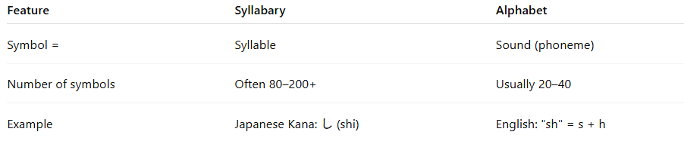

Feature | Syllabary | Alphabet
Symbol = | Syllable | Sound (phoneme)
Number of symbols | Often 80–200+ | Usually 20–40
Example | Japanese Kana: し (shi) | English: "sh" = s + h

Summary:
# Source: Chatgpt (GPT-4-turbo) at [7/21/2025]
A syllabic writing system is a system in which each symbol represents an entire syllable. It is well-suited to languages with a limited set of syllable types, and is different from alphabets, which break language down into individual sounds.

